Ideation Phase
Empathize & Discover

Date | 14 feb 2026
Team ID | LTVIP2026TMIDS24293
Project Name | Deep Learning Fundus Image Analysis for Early Detection of Diabetic Retinopathy
Maximum Marks | 4 Marks

Empathy Map Canvas:
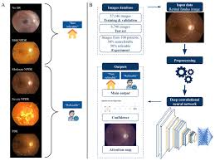

Pains (Problems / Challenges)  - Late Detection  - Diabetic retinopathy often shows no early symptoms  - Many patients are diagnosed only after vision damage  - Manual Screening Dependency  - Requires trained ophthalmologists  - Time-consuming and costly process  - Limited Access to Healthcare  - Rural and remote areas lack eye specialists  - Regular screening is difficult  - Human Error  - Fatigue and subjective judgment can affect diagnosis accuracy | Gains (Benefits / Value)  - Early Detection  - Identifies diabetic retinopathy at early stages  - Prevents vision loss and blindness  - Automated Diagnosis  - Deep learning models analyze images automatically  - Reduces workload on doctors  - High Accuracy  - CNN-based models detect subtle retinal patterns  - Consistent and reliable predictions  - Scalable Screening  - Can process large numbers of images quickly  - Suitable for mass screening programs

